|  |  |
| --- | --- |
| Ex.No.10 | **SIMULATION OF RIP PROTOCOL USING OPNET RIVERBED** |

|  |
| --- |
| **AIM:** |

To simulate the Routing Information Protocol using Opnet Riverbed 17.5

|  |
| --- |
| **THEORY:** |

**RIP:**

Routing Information Protocol (RIP) is a dynamic routing protocol which uses hop count as a routing metric to find the best path between the source and the destination network. It is a distance vector routing protocol which has AD value 120 and works on the application layer of OSI model. RIP uses port number 520.

|  |
| --- |
| **Installation and Procedure:** |

1. Download OPNET from the website

<https://cms-api.riverbed.com/portal/community_home>

1. Run the Installer and proceed next. Click on License Agreement and click next. After Installation give finish.
2. Open OPNET and create a new project

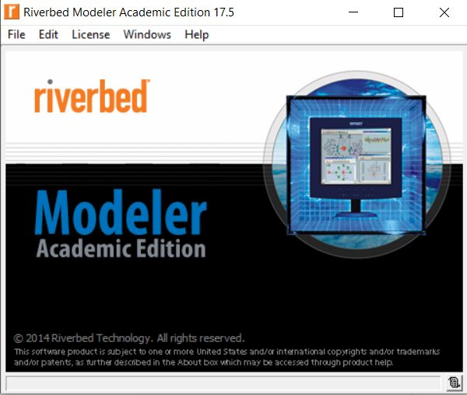 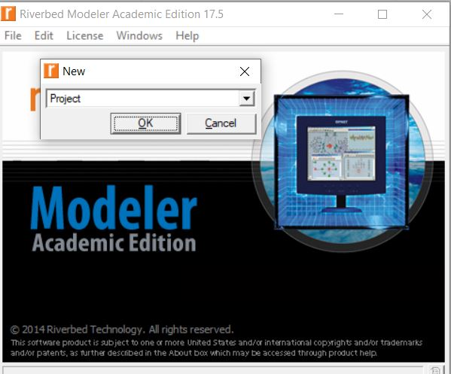

1. Give project name and scenario name
2. In the Startup Wizard give Create empty scenario and click next.
3. In the network scale select Campus and give next
4. Accept the defaults and proceed next. At last give finish. The project window is opened in OPNET.

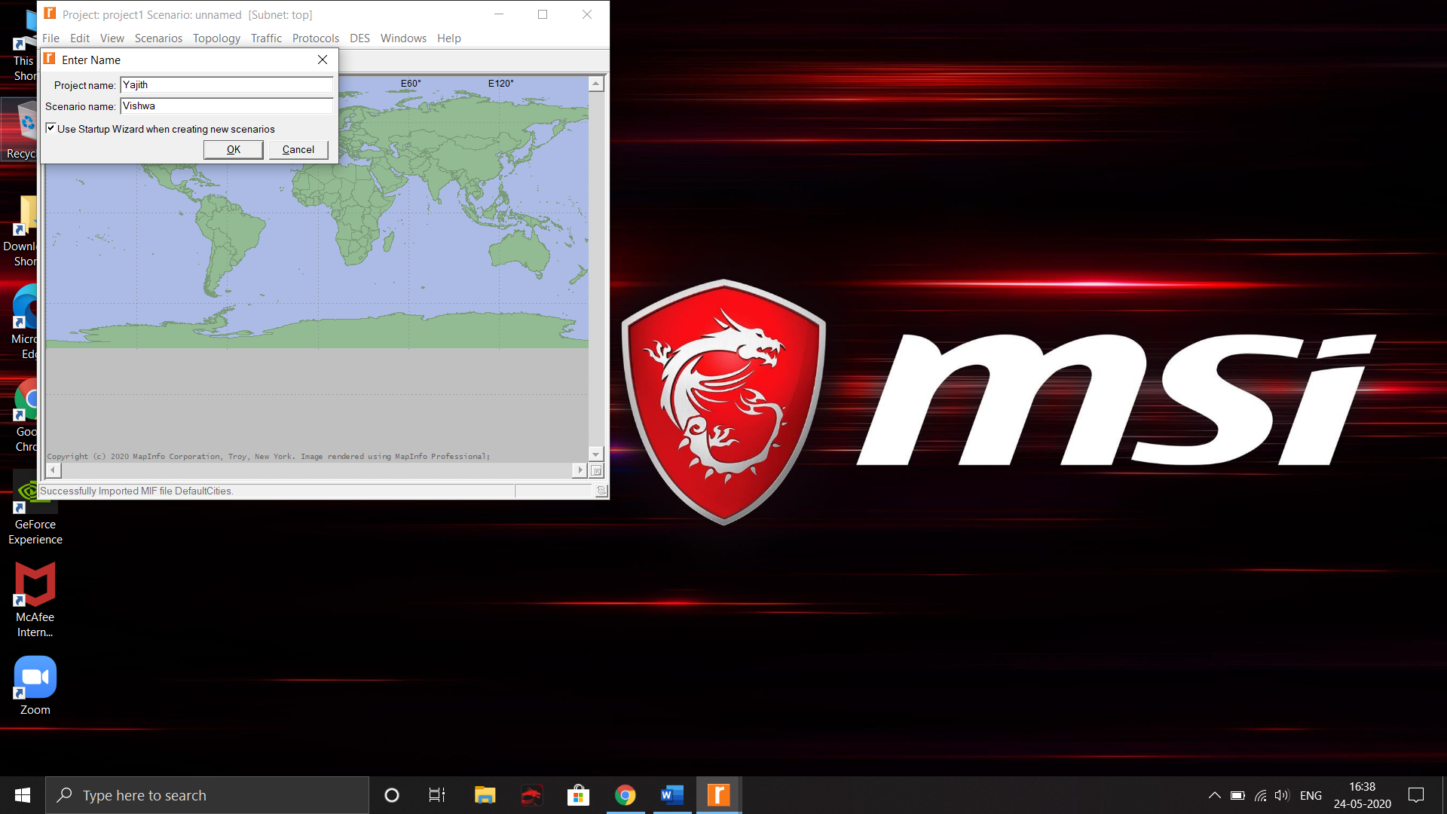

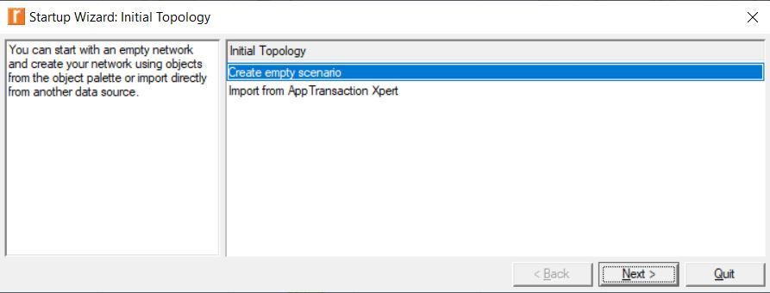

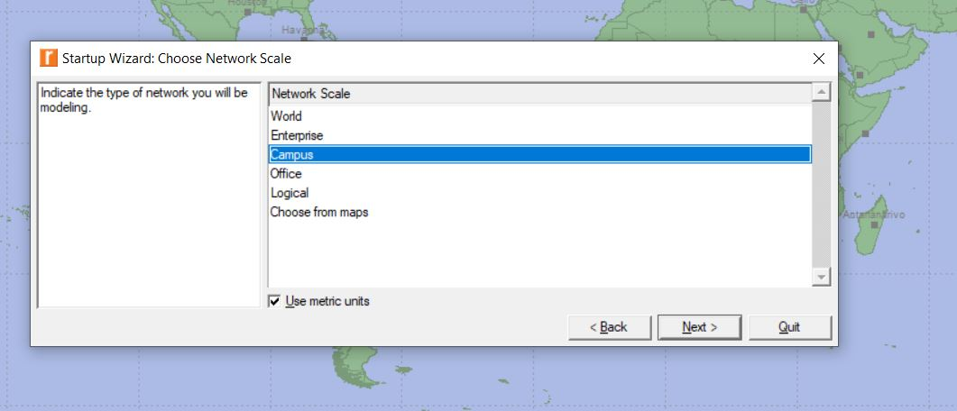

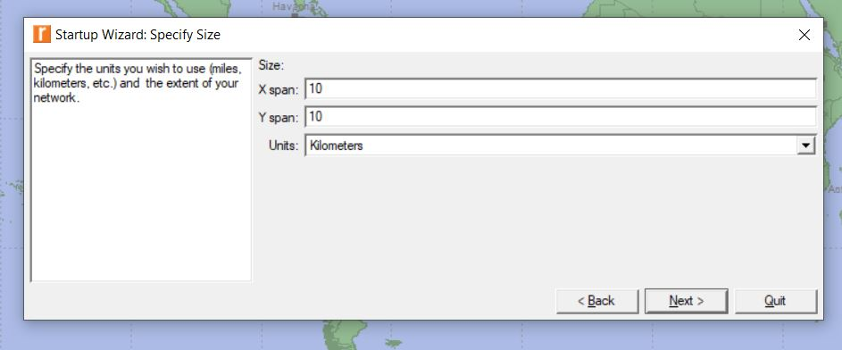

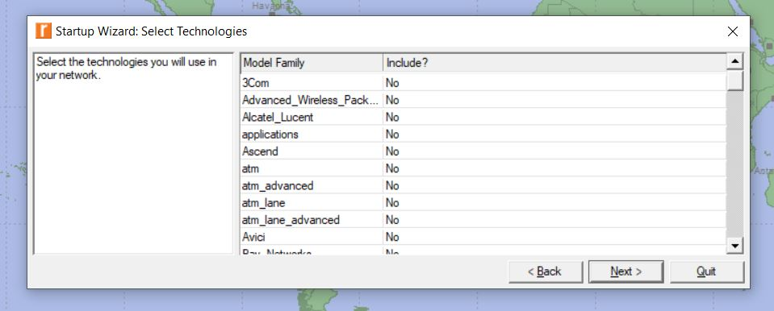

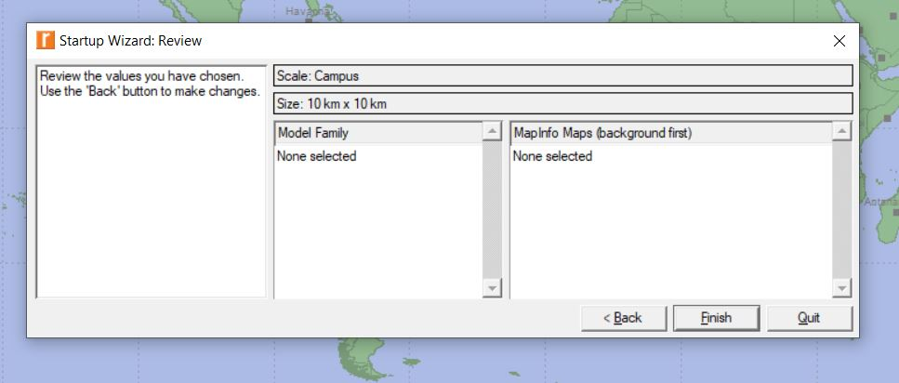

1. Open Object Palette and select ethernet4 router
2. Click and drag it to the project
3. Click and drag two 100BaseT_LAN to the project
4. For connecting the router and lan use 100BaseT duplex link

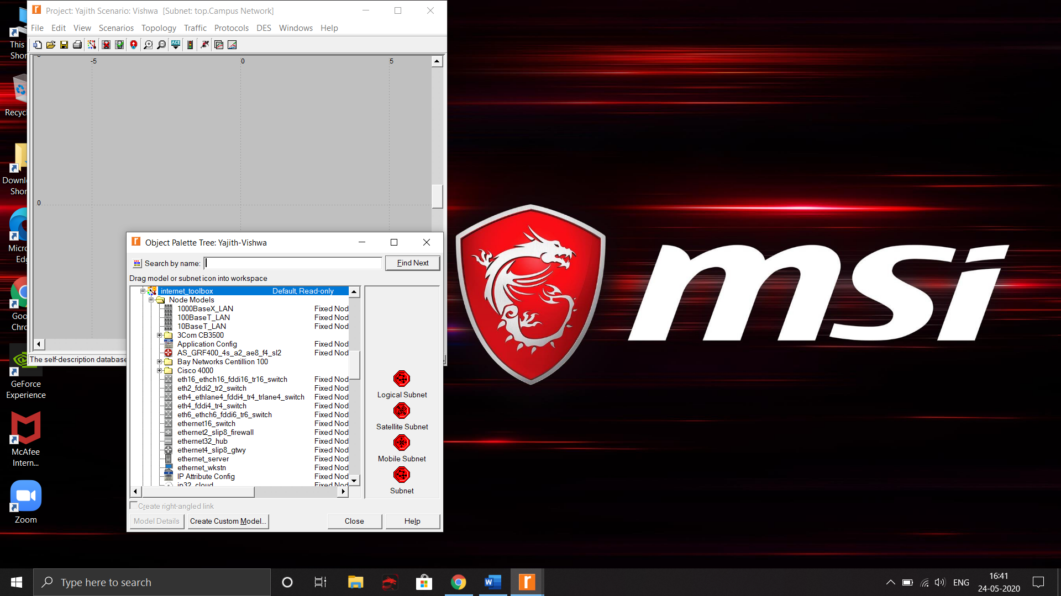

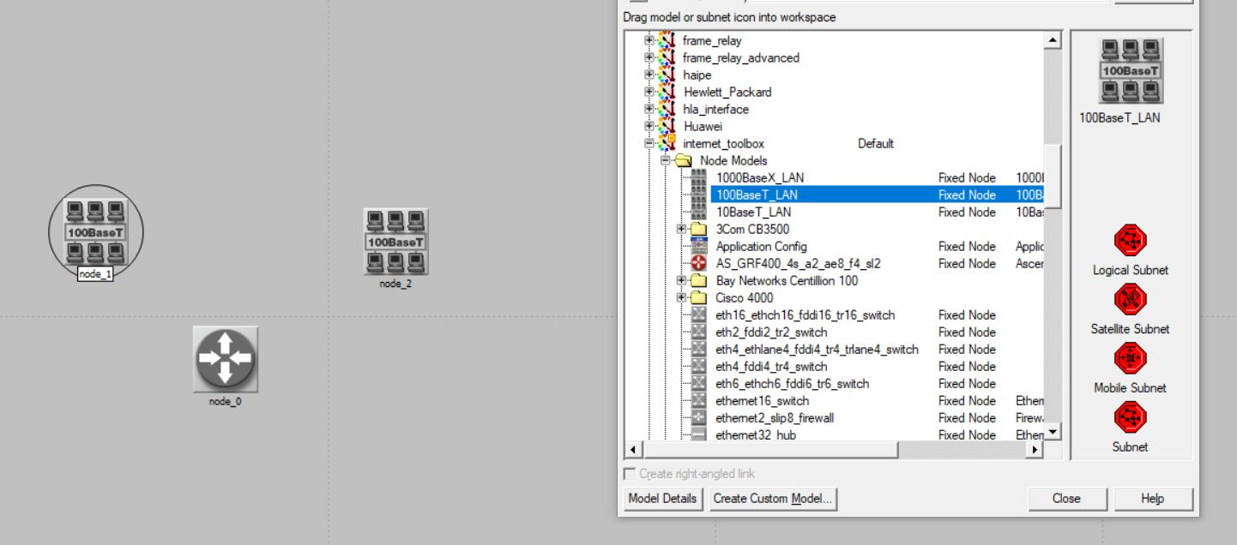

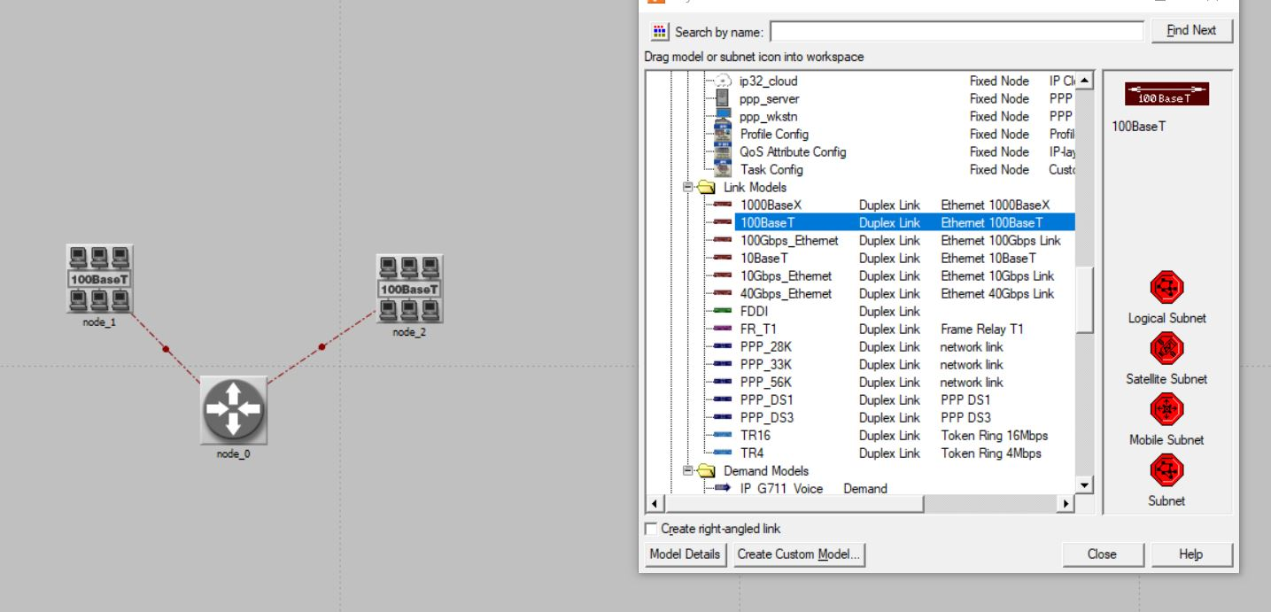

1. Right click the Router and Rename it as “Router”
2. Right click the router and select Edit Attributes

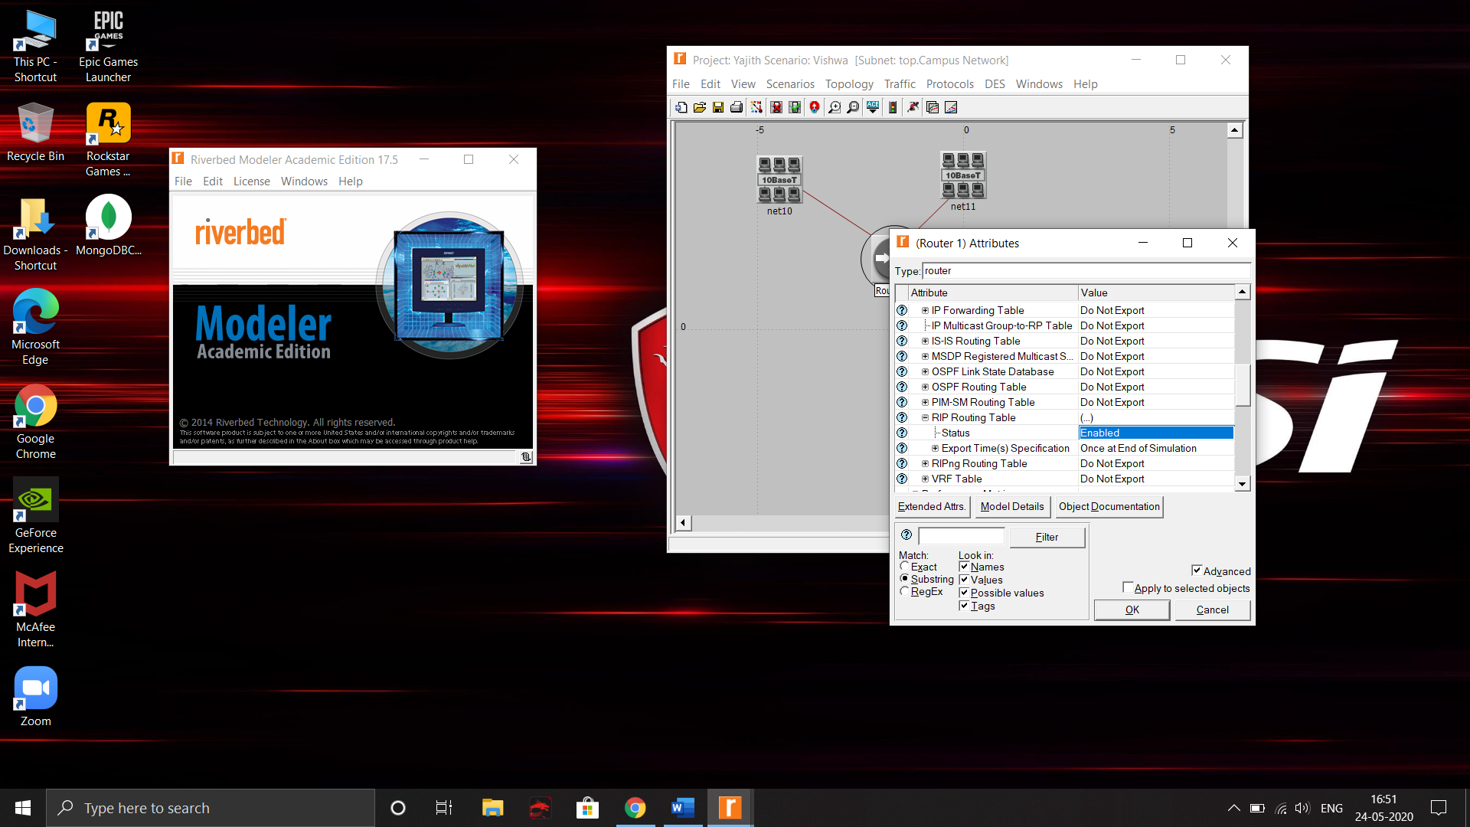

1. In the RIP Routing Table set Status = Enabled
2. In the Loop back interfaces set Number of Rows = 1
3. Select the router and two nodes and copy it
4. Paste it for 3 times to make a network

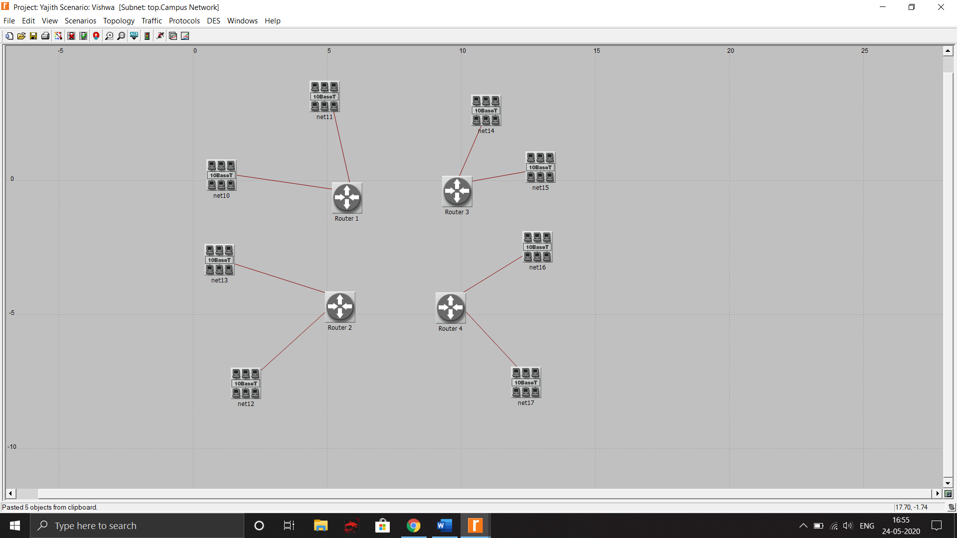

1. Open Object Palette and click on PPP DS3 duplex link to connect all the routers

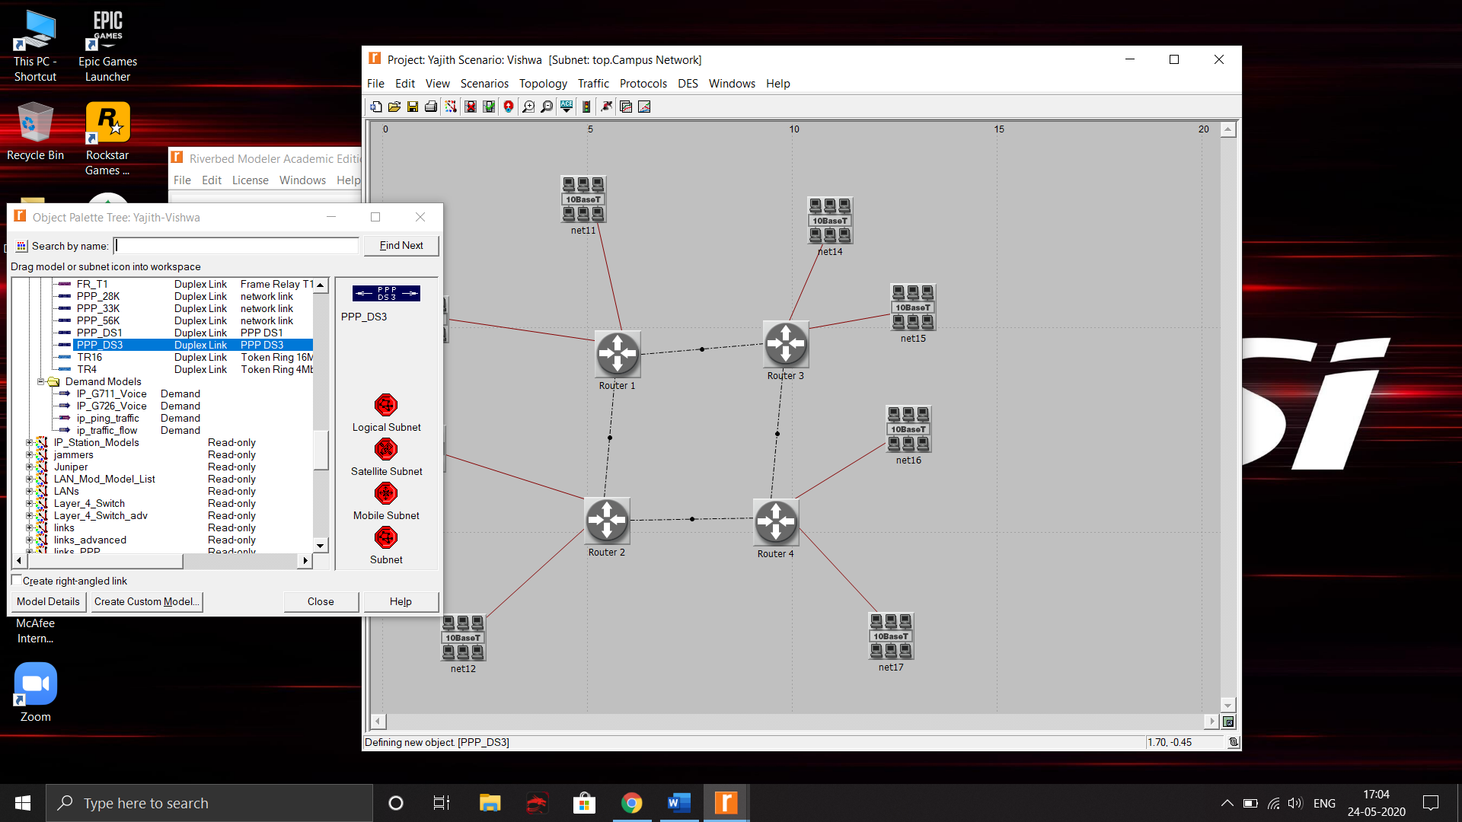

1. Right click inside the workspace and choose “Choose individual DES Statistics”

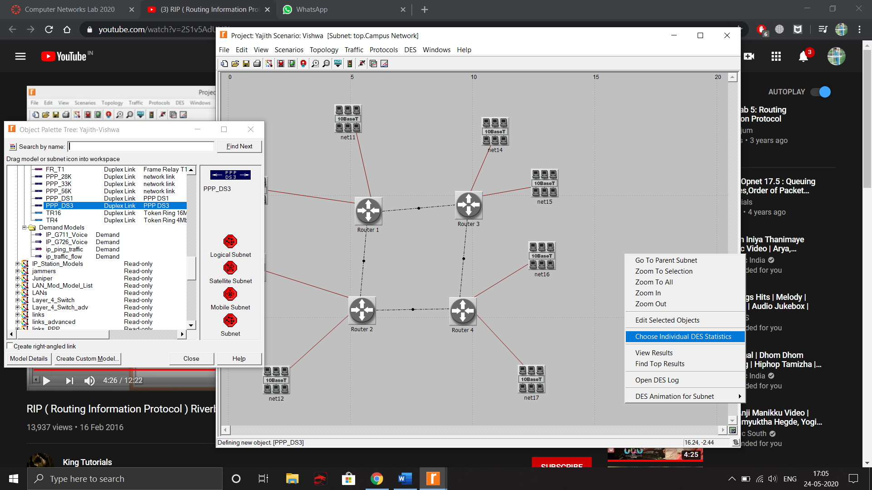

1. In the Choose Results box navigate to RIP and check Traffic Received, Traffic Sent

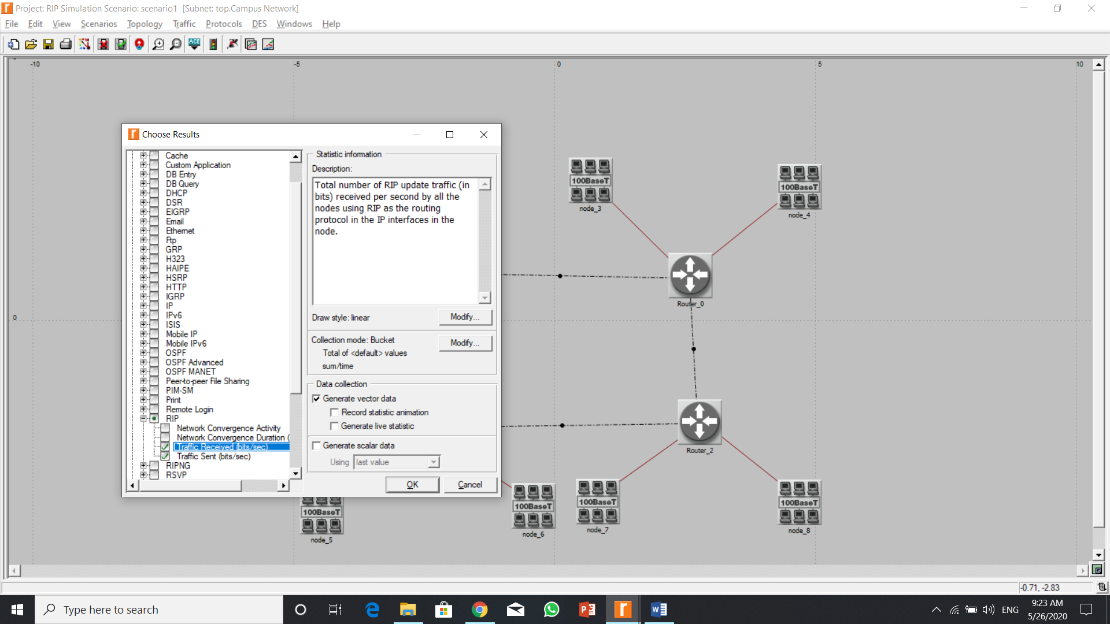

1. Expand the next cell and navigate to Route Table
2. Check total number of updates and give OK.

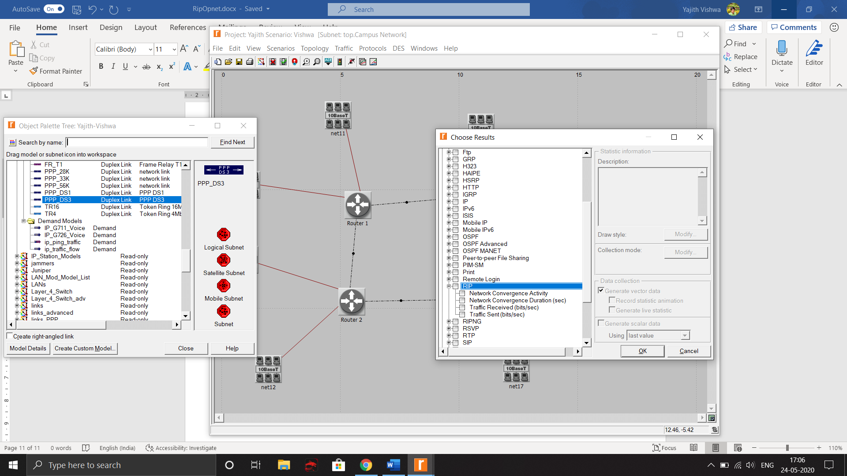

1. Run the simulation. Set duration to some time.

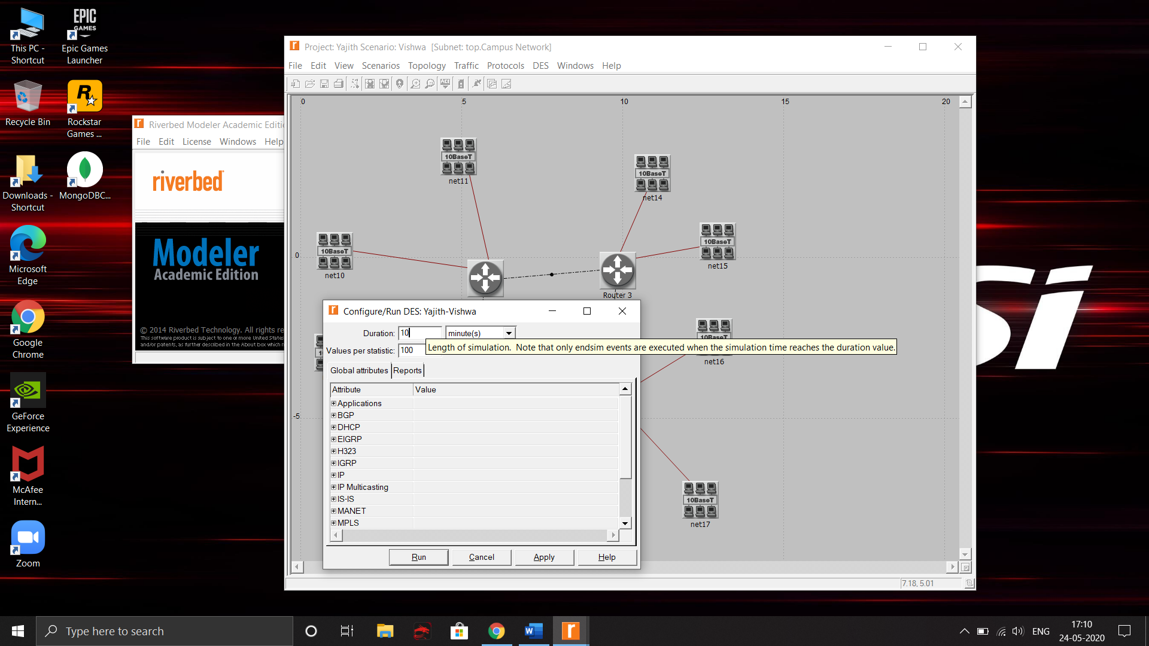

1. Under IP set IP Interface Addressing Mode to Auto Addressed/Export

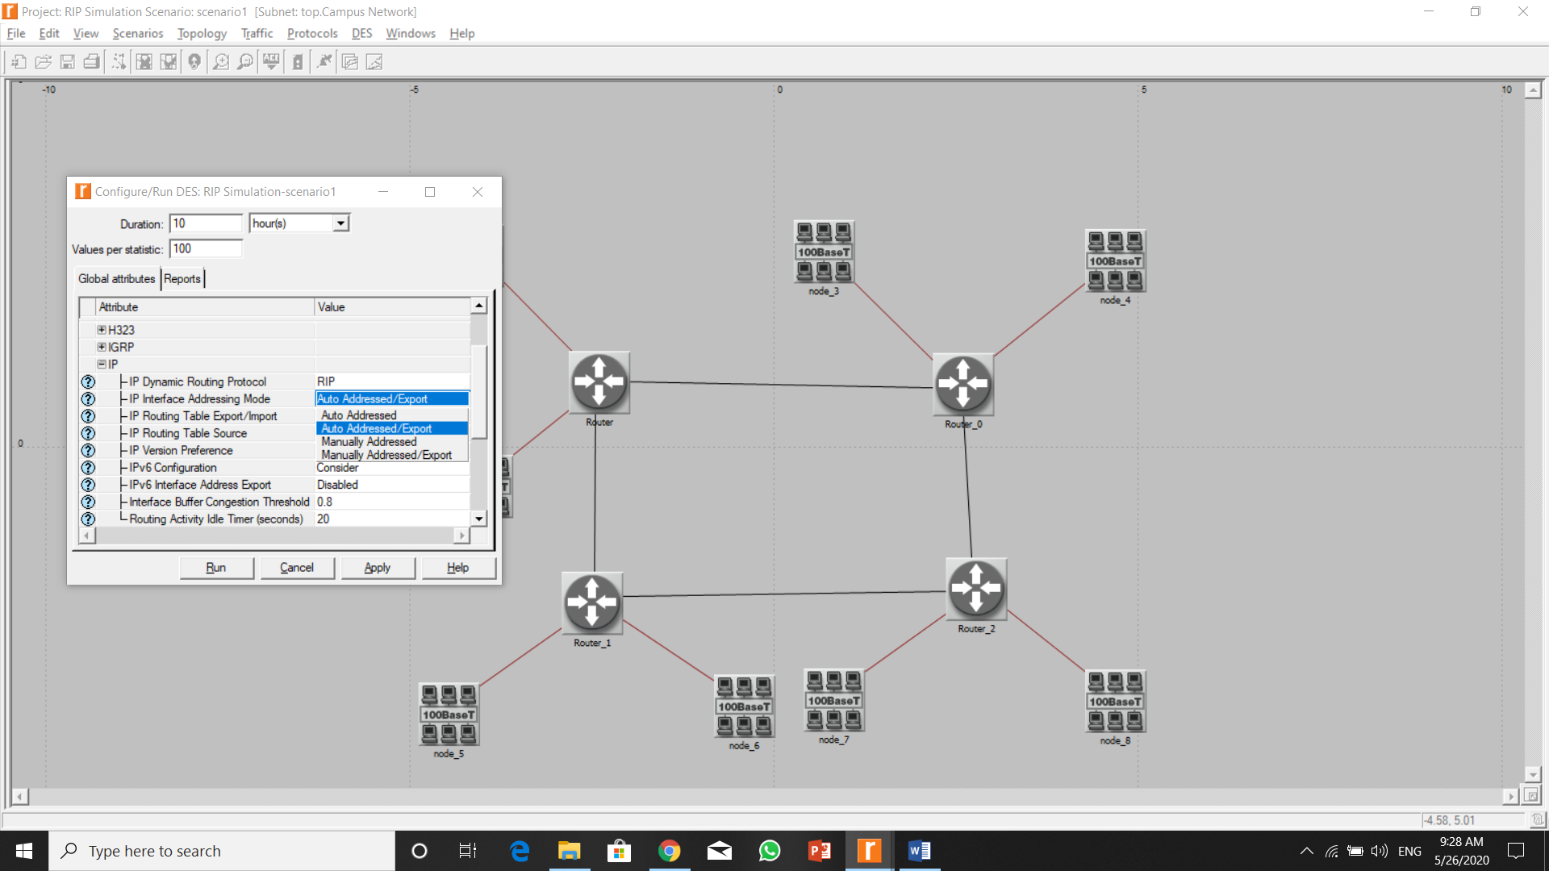

1. Set RIP sim efficiency to Disabled and run it.

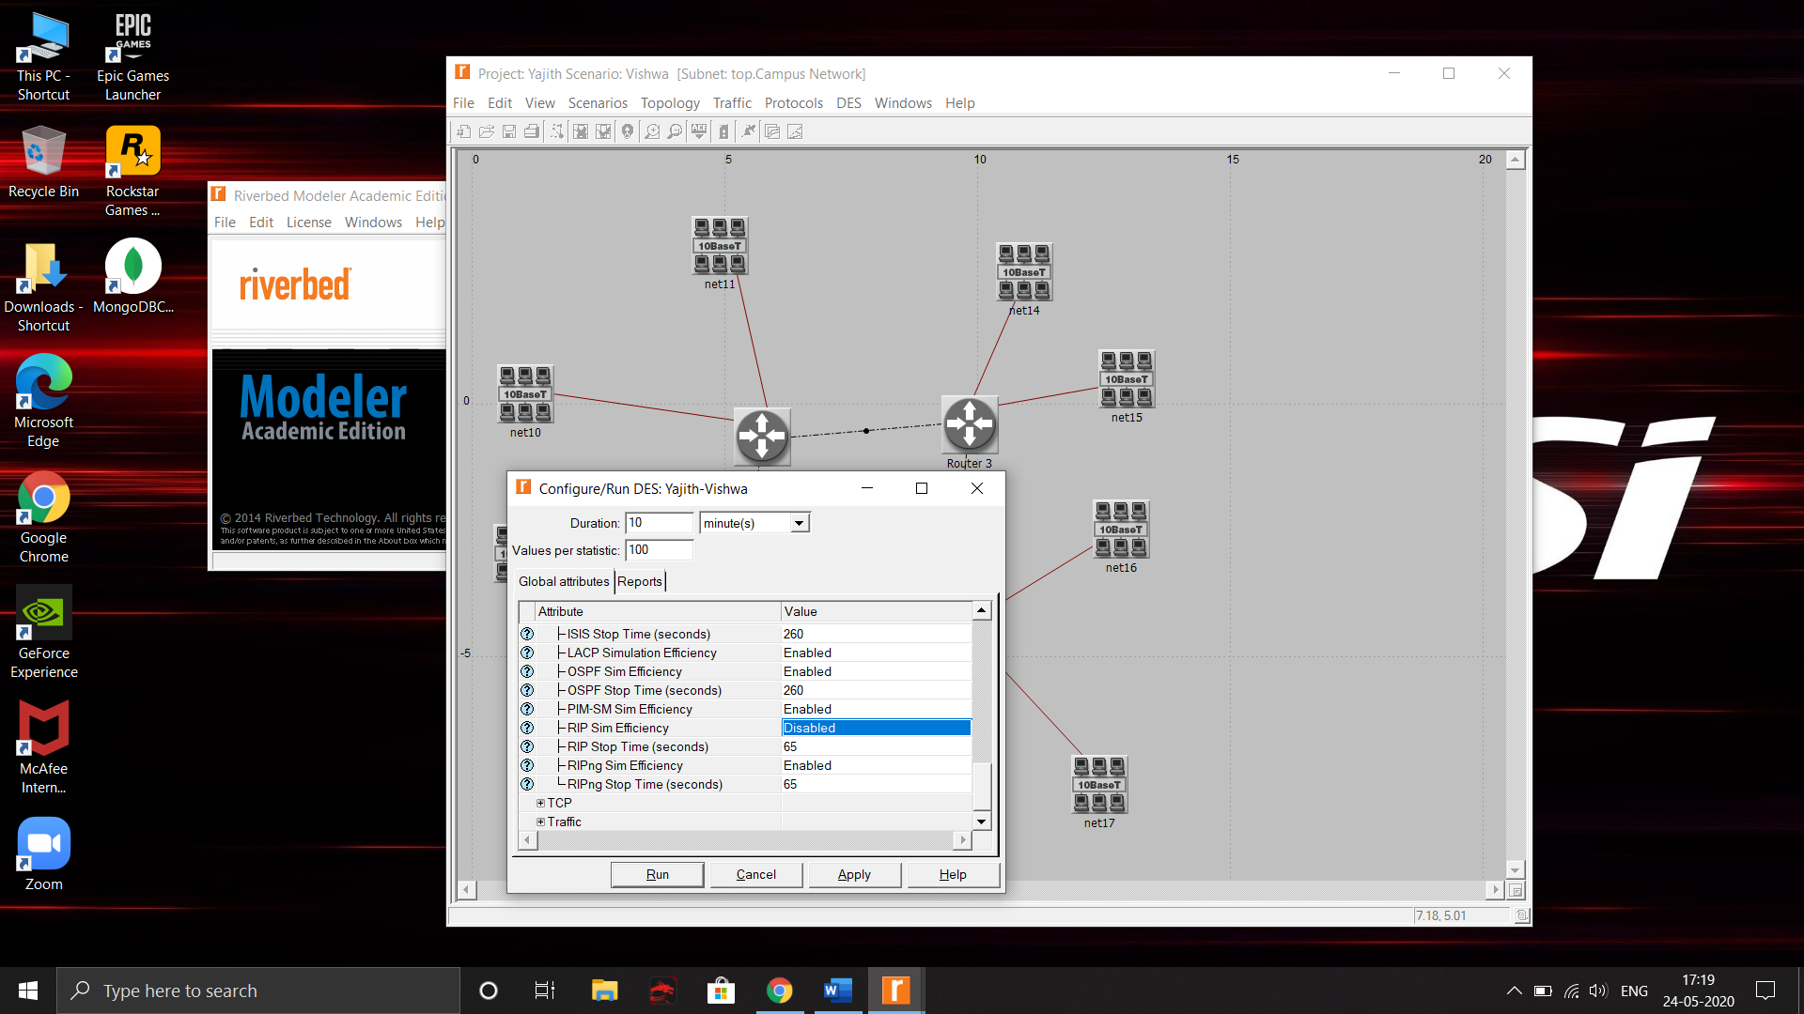

1. Duplicate the scenario and give the name as RIP Failure

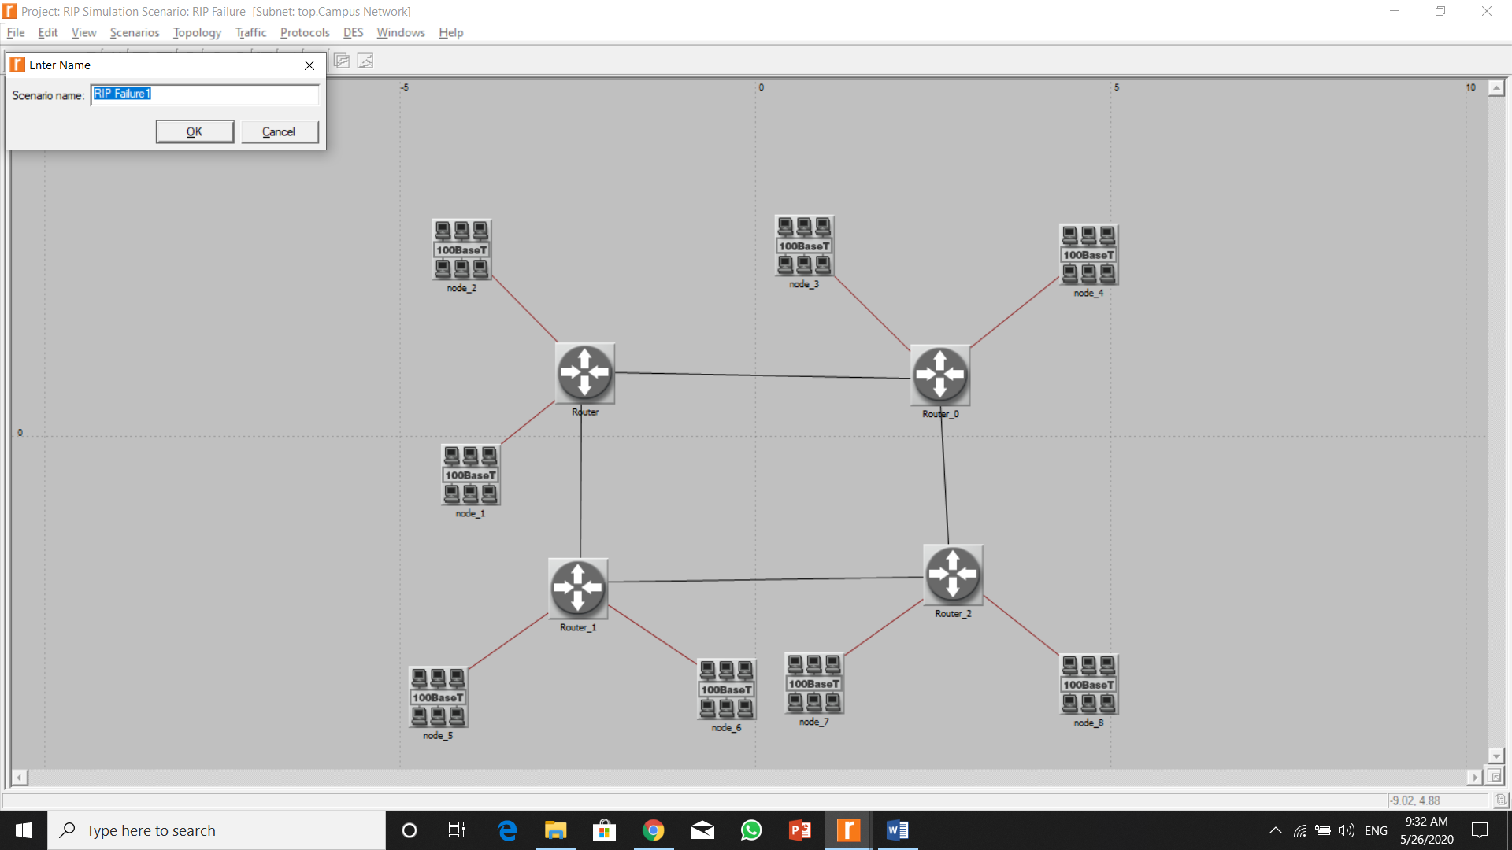

1. Select Failure Recovery from Object Palette and import to our project.

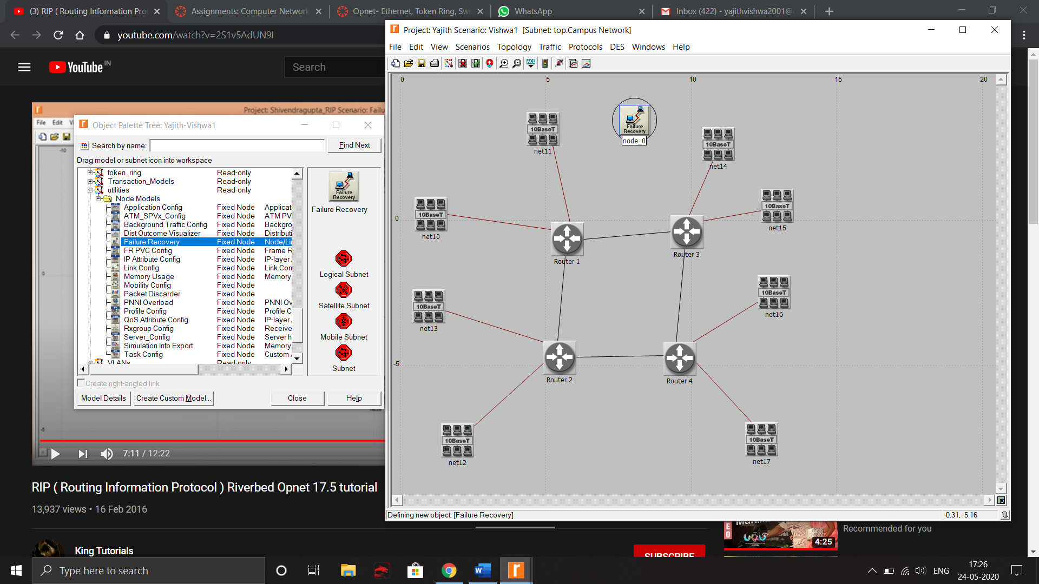

1. Right click it and select Edit Attributes

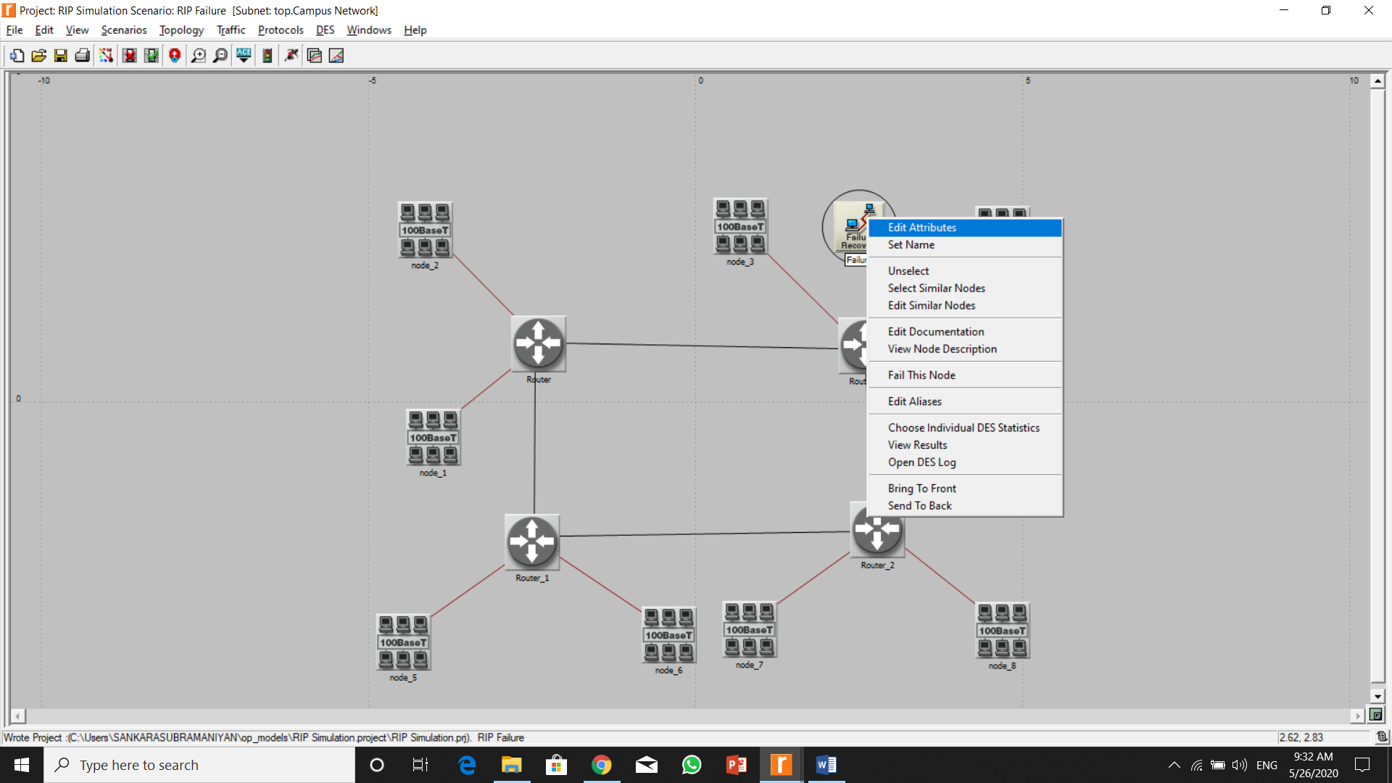

1. Set Link Failure/Recovery Specification -> Number of rows = 1

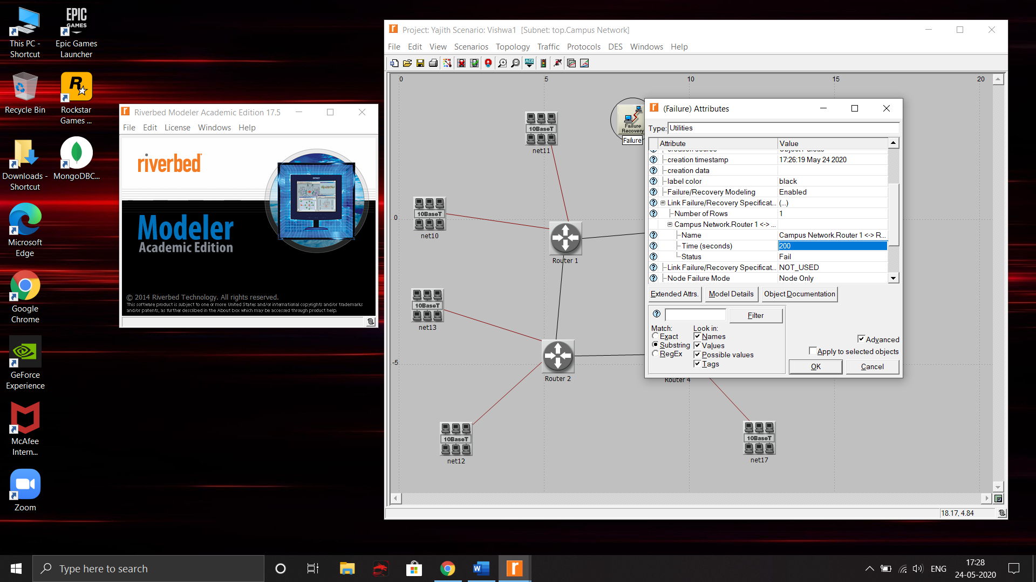

1. Set Campus Network Router -> Time = 200 Name = Router_0 – Router_2
2. Click Ok and Run the simulation



1. In the menu bar select DES -> Results -> Compare Results

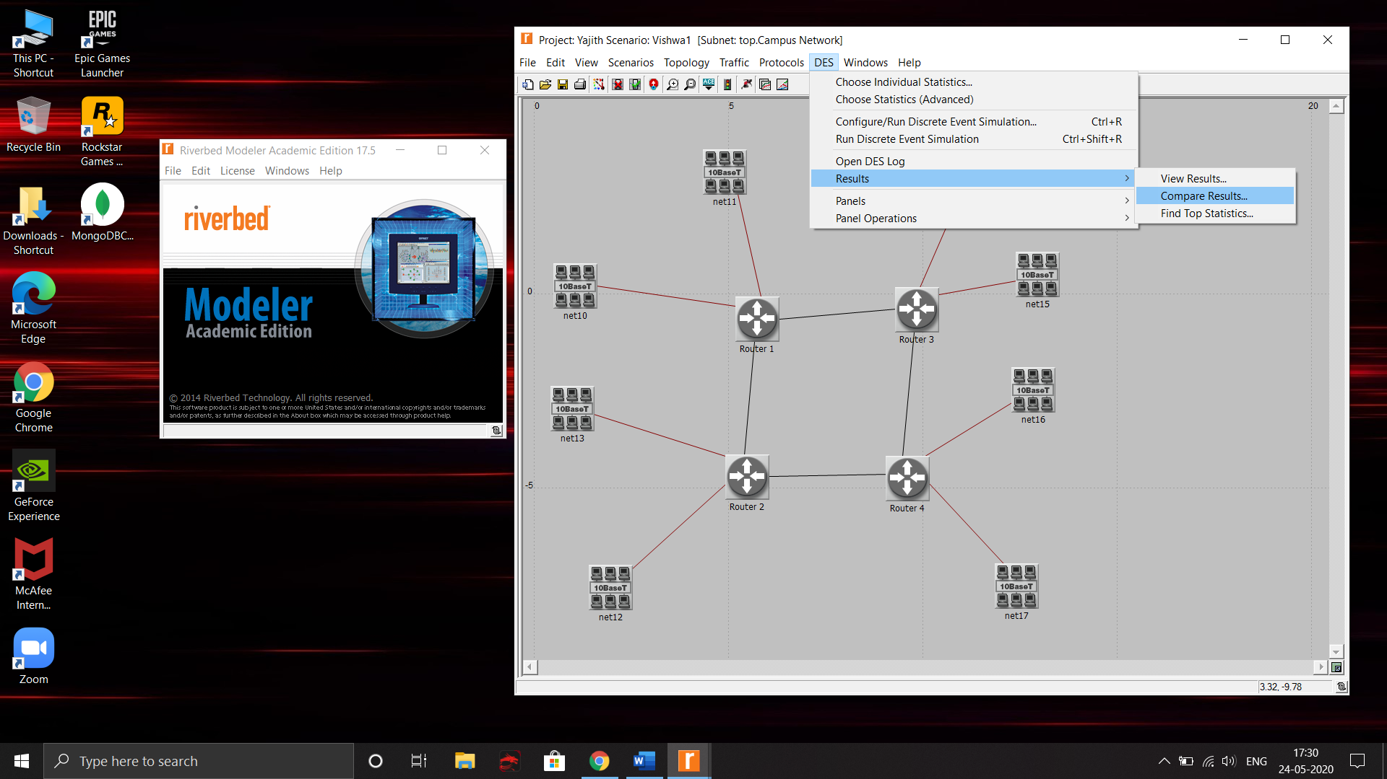

1. Select the scenarios to compare. Select the router to display the failures
2. The blue dot indicates the failure

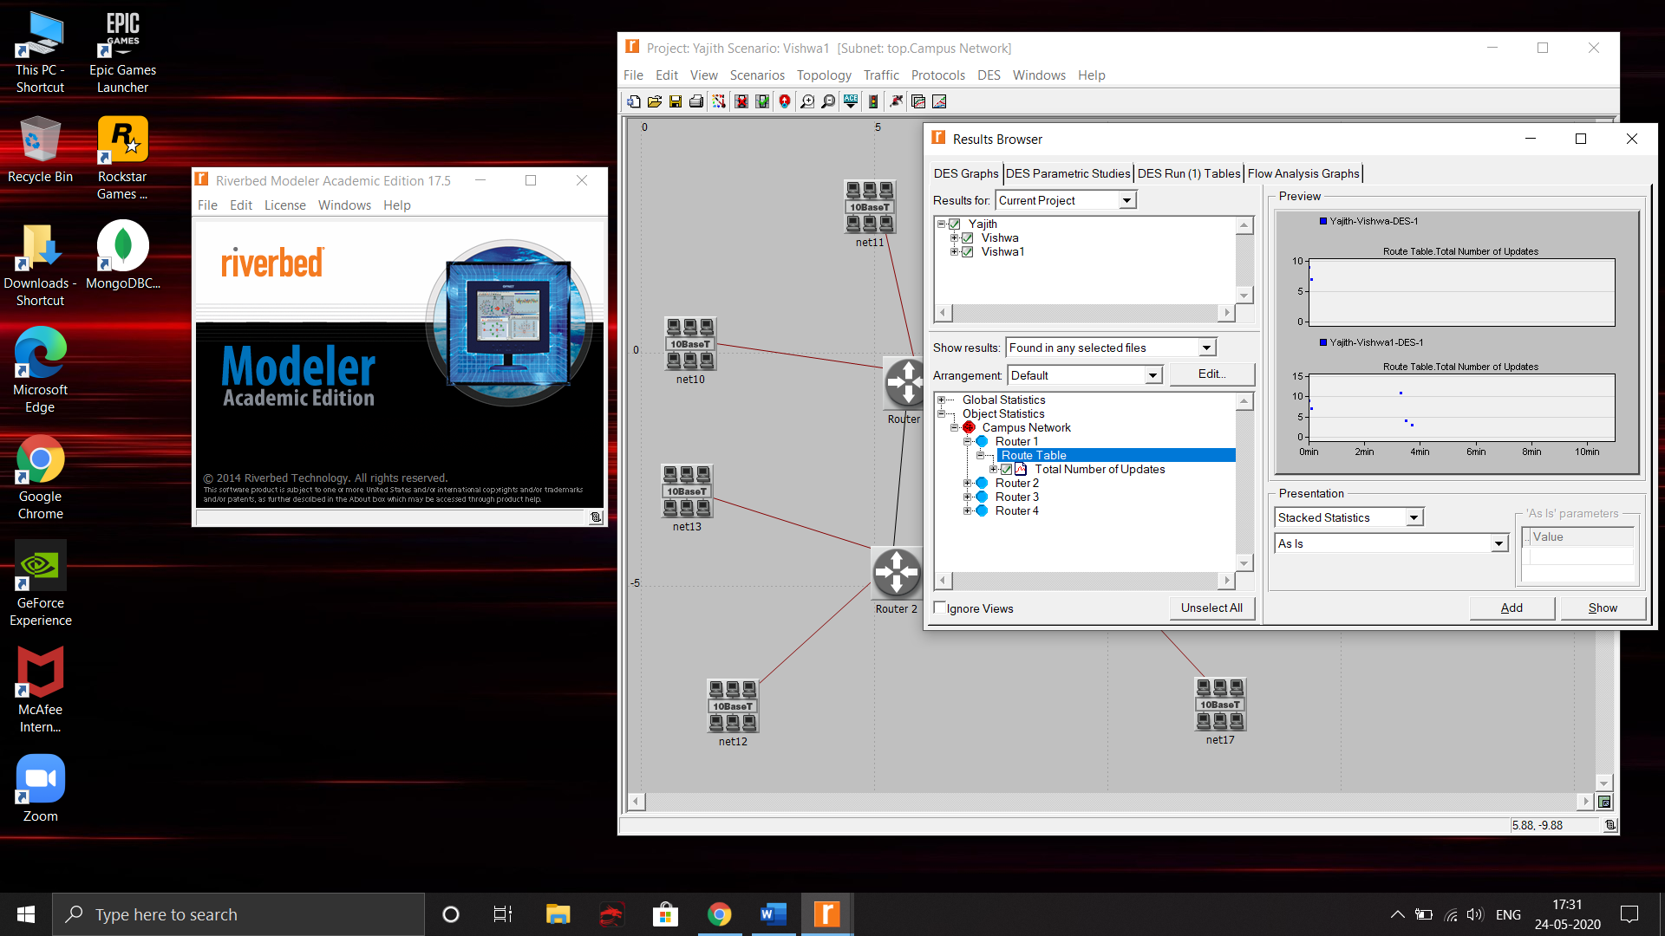

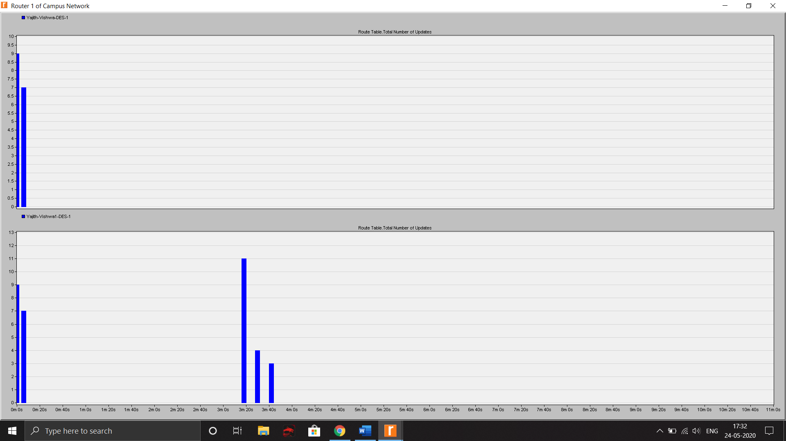

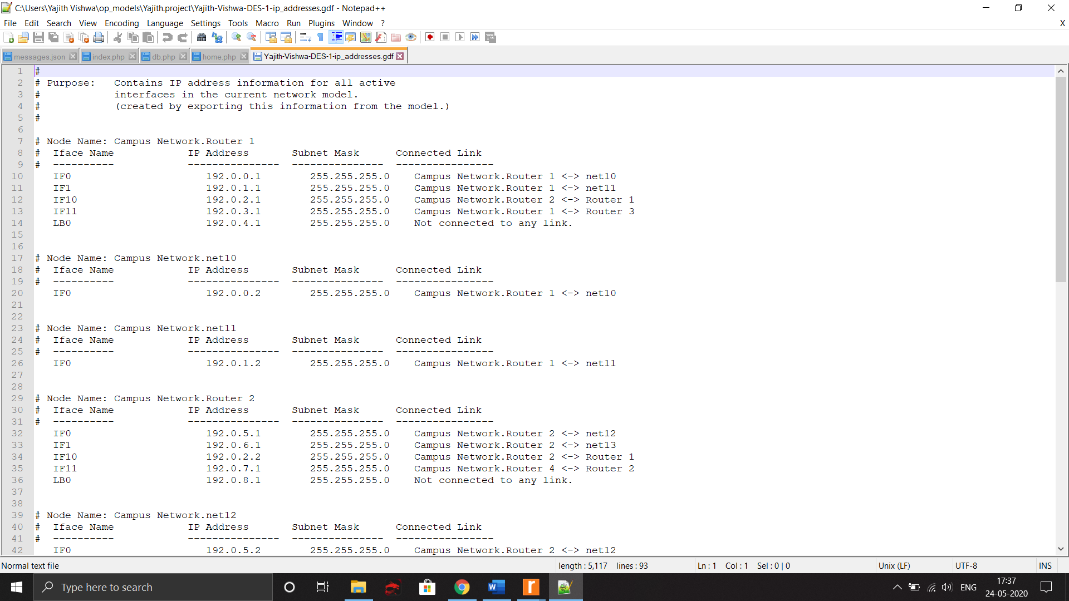

1. Go to Protocols -> IP -> Routing -> Export Routing tables.
2. The RIP table is displayed. Switch to the first scenario

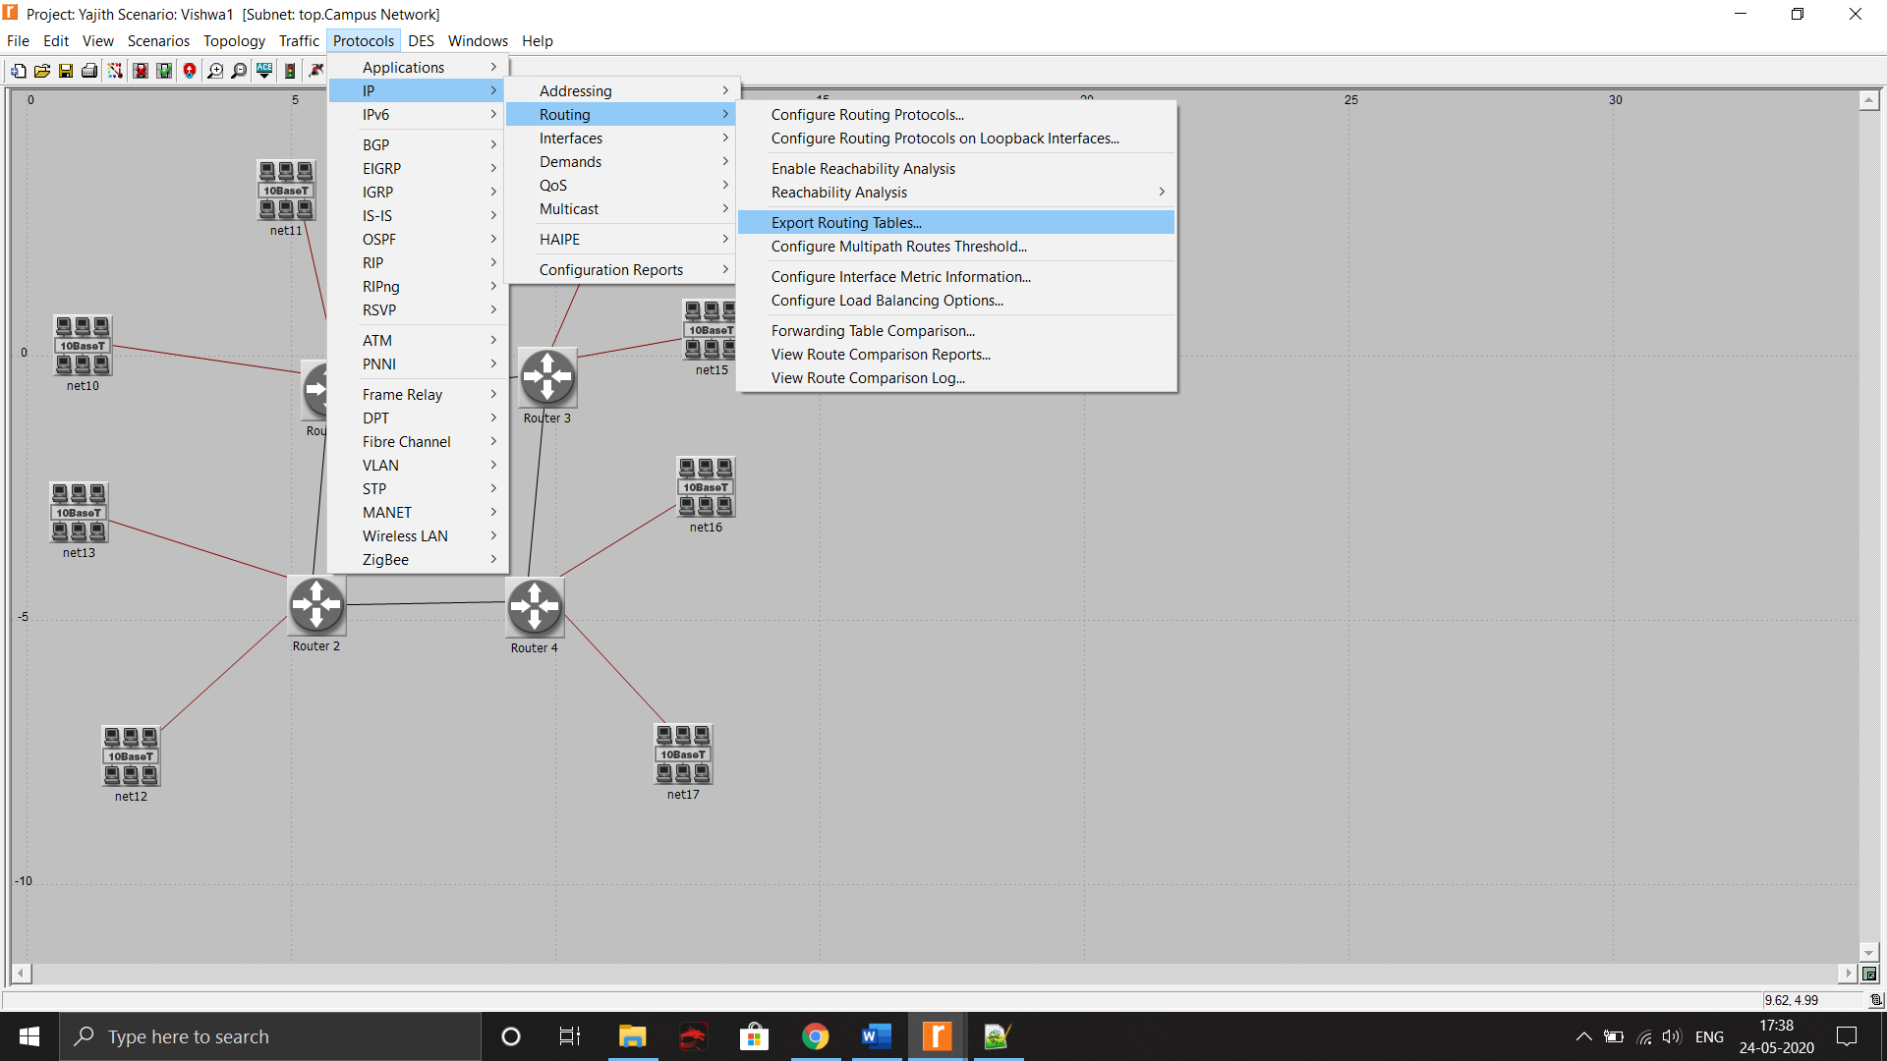

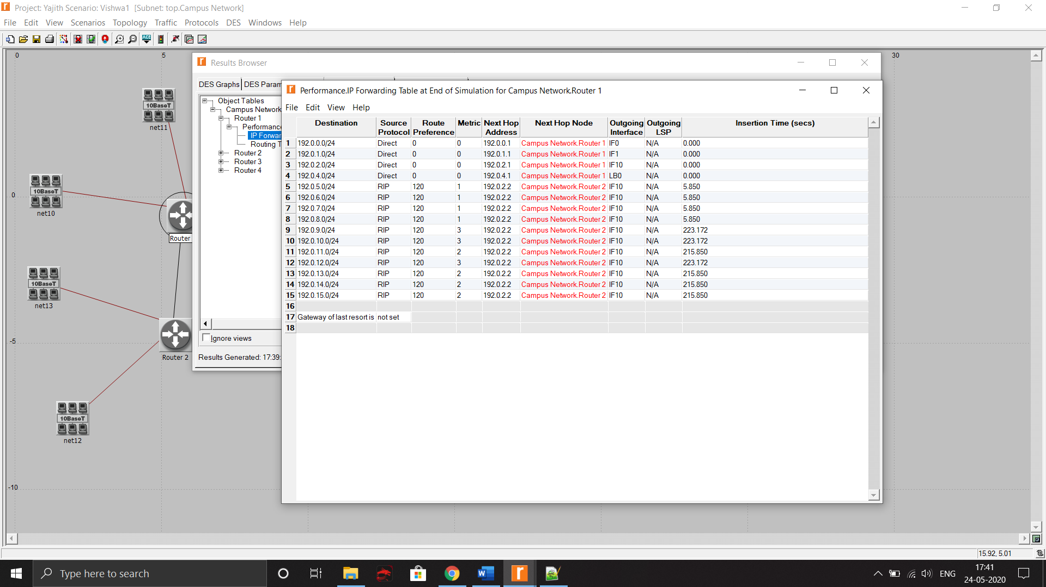

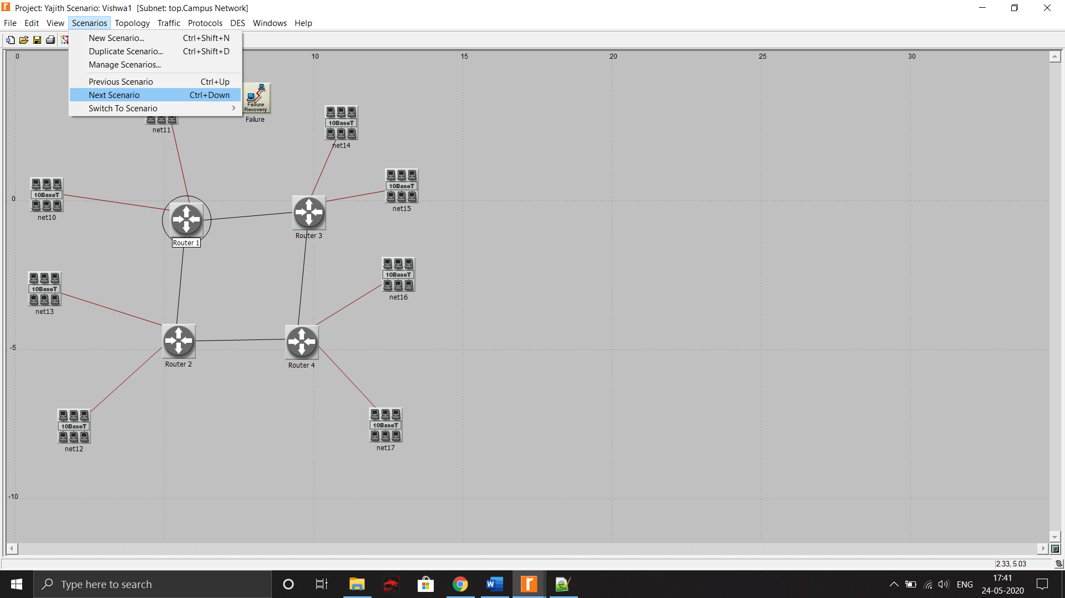

1. Export the routing table here also.
2. Then, run the simulation here.
3. Click DES -> Results -> View Results

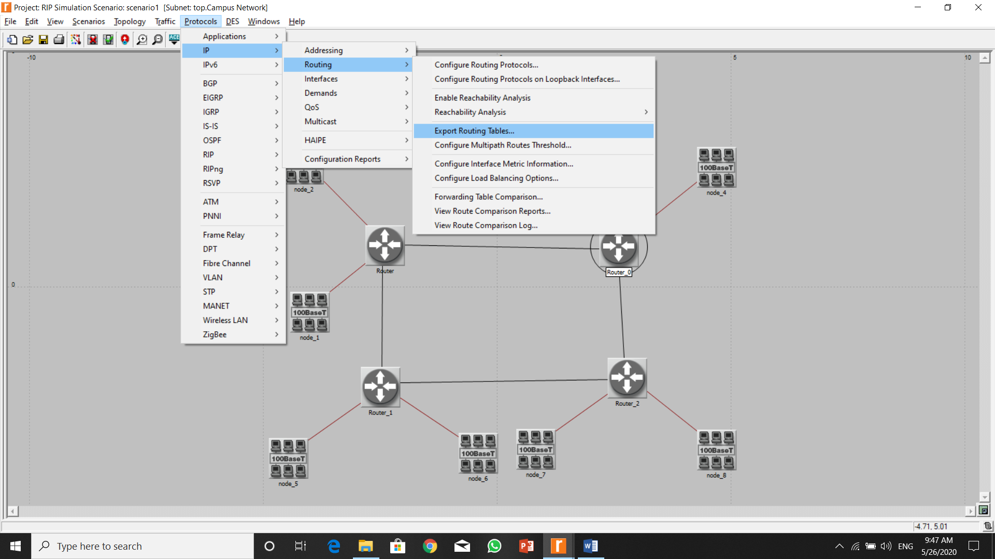

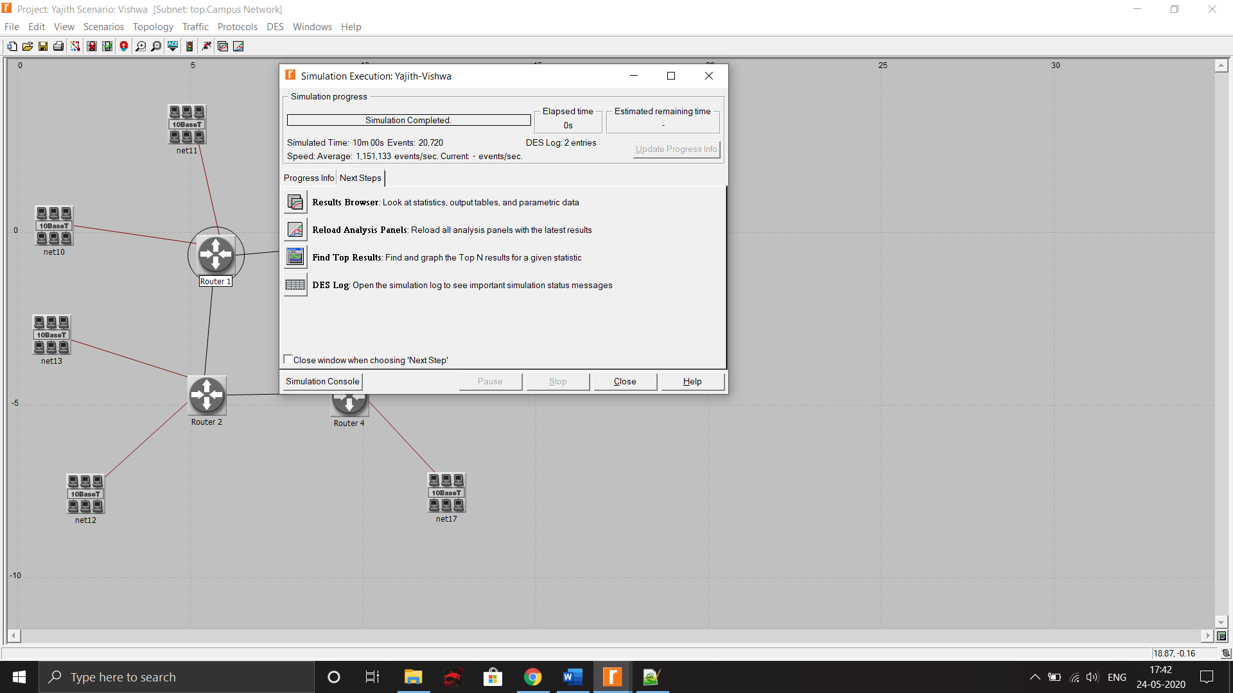

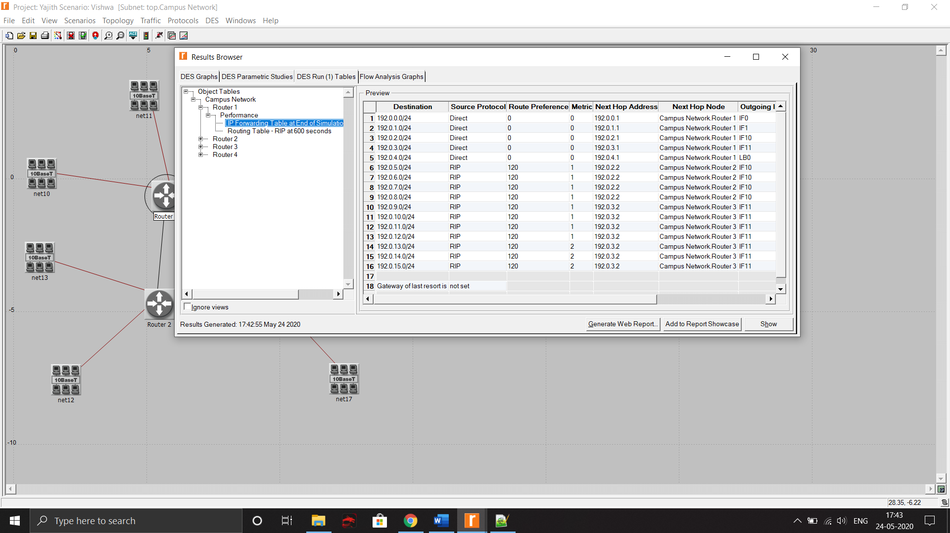

1. The RIP table is displayed here also (Without failure condition)

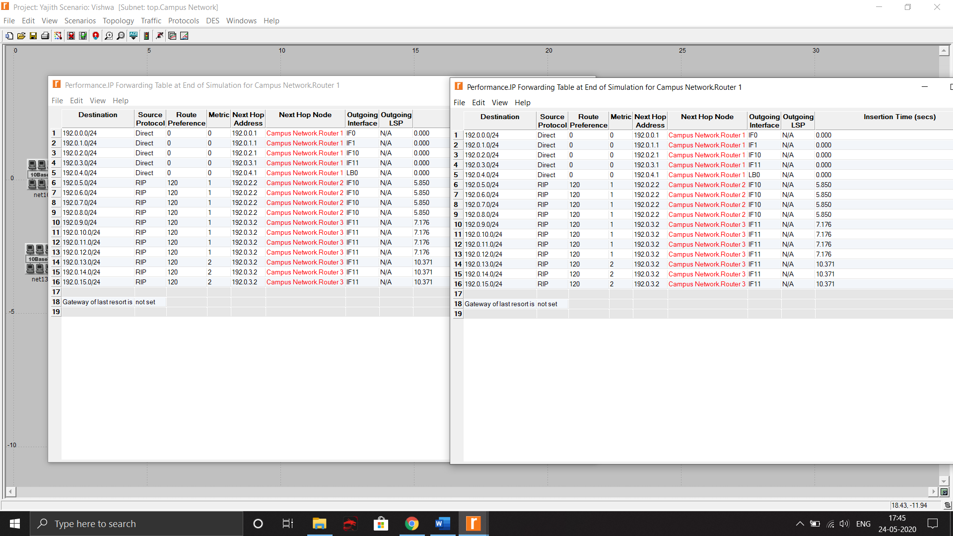

|  |
| --- |
| **RESULT:** |

Thus, the simulation of RIP protocol using riverbed is done. The RIP routing table is viewed and the results are verified.

**Evaluation:**

|  |  |  |
| --- | --- | --- |
| Parameter | Max Marks | Marks Obtained |
| Opnet Simulation | 10 |  |
| Clarity in explanation | 10 |  |
| Sub Total | 20 |  |
| Completion of experiment on time | 3 |  |
| Documentation | 7 |  |
| Total | 30 |  |
| Signature of the faculty with Date |  |  |